
ELECTRICITY THEFT DETECTION AND BILLING ANOMALY SYSTEM
A CAPSTONE PROJECT REPORT

A Capstone Project Report submitted in partial fulfilment of the requirements for the Course of

CSA0202 C Programming

to the award of the degree of

BACHELOR OF ENGINEERING IN ELECTRONICS AND COMMUNICATION ENGINEERING

Submitted by
K DHANUSH SRIVATAN (192524503)
C ABHINAY ADITHYA (192572115)
MD.HASEED (192521674)

Under the Supervision of

Dr. V. Jayasudha

SIMATS ENGINEERING
Saveetha Institute of Medical and Technical Sciences
Chennai-602105

SEPTEMBER 2026

BONAFIDE CERTIFICATE

This is to certify that the Capstone Project entitled “ELECTRICITY THEFT DETECTION AND TEST ANOMALY SYSTEM” has been carried out by K DHANUSH SRIVATAN (192524503), C ABHINAY ADITHYA (192572115) ,MD.HASEED (192521674) under the supervision of Dr. V. Jayasudha and is submitted in partial fulfilment of the requirements for the current semester of the B.E Electronics and Communication Engineering program at Saveetha Institute of Medical and Technical Sciences, Chennai.

COURSE COORDINATOR COURSE FACULTY

DR.M.SHAKEELA DR.V.JAYASUDHA Designation Branch / Department

Branch / CSE SIMATS Engineering, SIMATS Engineering, SIMATS, Chennai – 602105.
SIMATS, Chennai – 602105.

DECLARATION

We,K DHANUSH SRIVATAN (192524503), C ABHINAY ADITHYA (192572115) ,MD.HASEED (192521674), of the AIDS & CSE Department, SIMATS Engineering, Saveetha Institute of Medical and Technical Sciences, Chennai, hereby declare that the Capstone Project Work entitled “ELECTRICITY THEFT DETECTION AND TEST ANOMALY SYSTEM” is the result of our own Bonafide efforts. To the best of our knowledge, the work presented herein is original, accurate, and has been carried out in accordance with the principles of engineering ethics and academic integrity. All sources, references, data, and other materials used in the project have been appropriately acknowledged. We further declare that the data, results, analysis, and findings presented in this report have not been fabricated, falsified, or manipulated. Any external tools, software, datasets, computational resources, or AI-assisted tools used during the project have been appropriately disclosed. We confirm that all applicable ethical, academic, institutional, and professional requirements have been duly followed throughout the planning, execution, analysis, and documentation of the project.

Place:
Date:

Signature of the Students with Names
C ABHINAY ADITHYA (192572185
K DHANUSH SRIVATSAN (192524503)
MOHAMED HASID (192521674)

Individual Contribution Statement

Student  Name /  Register No. | Specific Responsibilities | Design &  Development Contribution | Testing &  Analysis  Contribution | Report Contribution | Approx.  Contribution  (%)
Deepan Kumar P | C server development, socket communication, system integration and overall project coordination | Developed the C server, handled socket communication and integrated the main application flow | Tested server communication, request handling and overall application flow | Chapter 1, Chapter 3, Chapter 4 and final documentation | 34%
Samuel I | User interface development and Lost & Found functionality | Worked on the browser interface, lost-item reporting and Find Item workflow | Tested user navigation, item search and Lost & Found functions | Chapter 2, Chapter 3 and implementation-related sections | 33%
Suthish P | Testing, verification workflow and project data organisation | workflow and project data organisation  Worked on item verification, request/status flow and supporting project data | Prepared test cases, checked application behaviour and analysed results | Chapter 4, Chapter 5 and appendices | 33%
Total |  |  |  |  | 100%

ABSTRACT

The Electricity Theft Detection and Billing Anomaly System is a C-based software application designed to monitor electricity consumption, manage consumer information, detect suspicious electricity usage, and identify billing anomalies. Electricity theft is a major challenge for power distribution organizations because illegal connections, meter tampering, bypassing of meters, and manipulation of meter readings can result in significant financial and energy losses.
The proposed system provides an organized platform for storing consumer information and maintaining electricity meter readings. It compares previous and current readings to calculate consumption and identify unusual patterns. The system uses anomaly detection techniques to identify sudden spikes, abnormal drops, and other suspicious consumption behaviors that may indicate electricity theft or meter manipulation.
The system is divided into three major modules. The first module manages consumer information and meter readings using C structures and file handling. The second module analyzes electricity consumption and detects possible theft using threshold-based detection techniques. The third module calculates monthly electricity bills, checks billing discrepancies, generates reports, and displays fraud summaries.
The project demonstrates the practical application of important C programming concepts such as structures, arrays, pointers, functions, and file handling. The system provides a console-based interface for entering information and viewing results. Although the current implementation is a software simulation and does not use physical smart meters or real-time IoT devices, it provides a foundation that can be extended into a smart electricity monitoring system.

Keywords
Electricity Theft, Billing Anomaly, Fraud Detection, Electricity Consumption, Smart Meter, C Programming, File Handling, Anomaly Detection.

TABLE OF CONTENTS

Sl.  No | Title | Page  No
i | CERTIFICATE FROM THE SUPERVISOR | ii
ii | DECLARATION BY THE CANDIDATE | iii
Iii | INDIVIDUAL CONTRIBUTION STATEMENT | iv
iv | ABSTRACT | v
v | LIST OF FIGURES | vi
vi | LIST OF TABLES | vii
vii | LIST OF ABBREVIATIONS | viii
1 | CHAPTER 1: Introduction
2 | CHAPTER 2: Literature Review
3 | CHAPTER 3: Engineering Design & Trade-offs, Sustainability,  Ethics, Safety, Risk & Security
4 | CHAPTER 4: Implementation, Testing & Results, Project  Management
5 | CHAPTER 5: Conclusion & Reflection
 | References
 | Appendices

CHAPTER 1
INTRODUCTION AND ENGINEERING PROBLEM
1.1 Background
Electricity is an essential resource used in homes, educational institutions, industries, commercial buildings, and public facilities. Electricity distribution companies are responsible for delivering electrical power to consumers and accurately measuring the amount of electricity consumed. However, electricity theft and billing fraud create serious challenges for efficient power distribution.
Electricity theft can occur in several forms. Consumers may illegally tap electricity lines, bypass electricity meters, manipulate meter readings, or damage meters to reduce the recorded amount of consumption. Such activities cause the actual electricity consumed to be different from the electricity recorded by the meter.
Traditional electricity theft detection methods often depend on manual inspection. Electricity board personnel may need to visit consumer locations and inspect meters, connections, and consumption records. This approach can be time-consuming and expensive. Suspicious consumption patterns may remain undetected until a physical inspection is performed.
The proposed Electricity Theft Detection and Billing Anomaly System addresses this problem through software-based monitoring and analysis. The system stores consumer details and meter readings and compares consumption values to identify unusual behavior.
The project is developed using the C programming language. It demonstrates how programming concepts such as structures, functions, arrays, pointers, and file handling can be used to build a practical electricity monitoring and fraud detection application.

1.2 Need for the Project
Electricity theft results in energy losses and financial losses for electricity distribution organizations. When electricity is consumed without being properly recorded, the distribution company cannot collect the appropriate payment for the electricity supplied.
A simple billing system only calculates the amount that a consumer needs to pay. It does not necessarily identify whether the recorded consumption is suspicious. Therefore, there is a need for a system that combines consumption monitoring, theft detection, and billing analysis.
The proposed system analyzes the difference between previous and current meter readings. Unusual increases or decreases can be flagged for further investigation. The system also provides different risk levels to help identify accounts that require attention.
The project is also useful from an academic perspective because it demonstrates the application of C programming to a real-world engineering problem.

1.3 Problem Statement
Electricity theft is a major problem in power distribution systems. Illegal power tapping, meter bypassing, meter tampering, and manipulated readings can cause electricity consumption to be under-recorded.
In addition, incorrect or manipulated billing information can result in undercharging or overcharging consumers. Manual inspection and billing verification may not be efficient for large numbers of consumers.
Therefore, a software system is required to maintain consumer records, store meter readings, analyze electricity consumption, identify suspicious patterns, detect potential theft, calculate electricity bills, and identify billing anomalies.
The proposed system provides a C-based approach to address these requirements through structured consumer management, anomaly detection, and billing analysis.

1.4 Project Aim
The main aim of the project is to develop a C-based Electricity Theft Detection and Billing Anomaly System that can monitor consumer electricity usage and identify possible fraudulent activities.
The specific aims are:
- To develop a system for registering electricity consumers.
- To store and manage consumer meter readings.
- To calculate electricity consumption from meter readings.
- To identify unusual consumption patterns.
- To detect possible electricity theft.
- To identify possible meter bypass or tampering patterns.
- To calculate monthly electricity bills.
- To detect billing discrepancies.
- To generate fraud and billing reports.
- To demonstrate the use of C programming concepts in a practical application.

1.5 Project Objectives
The major objectives of the project are:
- To develop an organized consumer management system.
- To provide consumer registration functionality.
- To maintain previous and current meter readings.
- To calculate electricity consumption.
- To search and update consumer information.
- To detect sudden increases in consumption.
- To detect unusually low or zero consumption.
- To identify possible illegal power tapping.
- To assign risk levels to suspicious consumers.
- To calculate electricity bills.
- To identify billing anomalies.
- To generate formatted reports.
- To maintain records using file handling.

1.6 Scope
The scope of the project includes consumer management, meter reading management, electricity theft detection, and billing analysis.
The system includes:
- Consumer registration.
- Consumer information management.
- Meter number management.
- Previous meter reading storage.
- Current meter reading storage.
- Consumption calculation.
- Consumer searching.
- Consumer information updating.
- File-based data storage.
- Spike detection.
- Drop detection.
- Illegal tap detection.
- Fraud risk classification.
- Billing calculation.
- Billing anomaly detection.
- Report generation.
- Fraud summary generation.
The current project is designed as a software simulation and does not directly communicate with physical smart meters or IoT devices.

1.7 Expected Engineering Outcome
The expected engineering outcome is a functional C-based prototype capable of managing consumer records, analyzing electricity consumption, detecting suspicious usage patterns, calculating electricity bills, and generating reports.
The system is expected to demonstrate how a software-based approach can assist in identifying possible electricity theft and billing anomalies.
The system can also serve as a foundation for future development involving IoT smart meters, real-time monitoring, artificial intelligence, machine learning, web dashboards, and mobile applications.

CHAPTER 2
LITERATURE REVIEW AND EXISTING SOLUTIONS
2.1 Review Method
The literature review focuses on electricity theft detection, electricity consumption analysis, smart meter technology, billing anomaly detection, and automated fraud identification.
The review considers traditional electricity inspection methods as well as software-based approaches that analyze consumer consumption patterns.

2.2 Review of Existing Work
Traditional electricity theft detection depends mainly on physical inspection of electricity meters and connections. Electricity board personnel inspect suspicious consumers based on complaints, unusual bills, or field observations.
Although manual inspection can identify physical tampering, it requires considerable time and human resources.
Digital electricity monitoring systems provide improved methods for storing and analyzing consumer consumption information. Consumption data can be compared over time to identify unusual patterns.
Smart meter technologies can provide frequent electricity readings and allow electricity distribution organizations to analyze consumption data more effectively. Advanced systems can also use machine learning techniques to identify complex theft patterns.
The proposed project applies the basic concept of consumption-based anomaly detection in a C programming environment.

2.3 Comparative Analysis
Existing Approach | Advantages | Limitations | Relevance
Manual Inspection | Simple and familiar | Slow and expensive | Problem addressed
Traditional Meter Reading | Easy to implement | Limited analysis | Basic monitoring
Basic Billing System | Calculates bills | Does not detect theft | Billing foundation
Smart Meter System | Provides frequent readings | Requires hardware | Future enhancement
Proposed System | Combines monitoring, theft detection and billing | Prototype limitations | Selected approach
The proposed system combines consumer management, electricity theft detection, and billing anomaly detection in a single application.

2.4 Research / Engineering Gap
Existing manual approaches mainly depend on physical inspection and periodic meter reading. Such methods may not identify suspicious consumption patterns quickly.
A basic billing system can calculate electricity charges but does not necessarily determine whether the recorded consumption is suspicious.
The engineering gap is therefore the absence of an integrated system that can store consumer information, analyze meter readings, identify abnormal consumption, detect potential theft, and verify billing information.
The proposed system attempts to address this gap through a unified C-based application.

2.5 Proposed Contribution
The proposed contribution is a software-based electricity monitoring system that integrates:
Consumer Management → Meter Reading → Consumption Analysis → Theft Detection → Risk Classification → Billing → Billing Anomaly Detection → Report Generation
The system provides a simple foundation for detecting suspicious electricity consumption and identifying accounts that may require further investigation.

CHAPTER 3
ENGINEERING DESIGN & TRADE-OFFS, SUSTAINABILITY, ETHICS, SAFETY, RISK & SECURITY
3.1 Requirements
Stakeholder / User Requirements
Stakeholder | Requirement
Consumer | Accurate electricity billing
Electricity Board | Consumer and meter management
Fraud Detection Team | Identify suspicious consumption
Billing Department | Calculate and verify bills
Administrator | Review fraud alerts and reports
Functional Requirements
- Add consumer.
- Record meter reading.
- Search consumer.
- Update consumer information.
- Store records in files.
- Analyze electricity consumption.
- Detect consumption spikes.
- Detect abnormal consumption drops.
- Identify possible illegal connections.
- Assign fraud risk levels.
- Generate electricity bills.
- Check billing anomalies.
- Generate reports.
Non-Functional Requirements
- Usability: The system should be simple to operate.
- Reliability: Valid inputs should produce consistent results.
- Accuracy: Consumption and billing calculations should be accurate.
- Maintainability: The modular structure should allow future improvements.
- Security: Consumer information should be protected.
- Performance: The system should process consumer records efficiently.

3.2 Constraints & Applicable Standards
The project is implemented as a C-based software simulation. The current version uses manually entered meter readings and file-based storage.
The system does not include physical smart meters, real-time IoT communication, user authentication, or graphical interfaces. These features can be added in future versions.
The project follows standard C programming practices and uses structured programming techniques.

3.3 Design Specifications
Parameter | Target / Requirement | Priority
Consumer Record | Store consumer information | High
Meter Reading | Store previous/current readings | High
Consumption Analysis | Calculate electricity usage | High
Theft Detection | Detect suspicious patterns | High
Risk Classification | Assign risk levels | High
Billing | Calculate monthly charges | High
Report | Generate fraud/billing report | Medium
File Storage | Save consumer records | High

3.4 Alternative Solutions & Evaluation
Alternative 1: Manual Inspection
Manual inspection is simple but requires physical visits and significant human resources.
Alternative 2: Basic Billing Software
A billing-only system can calculate electricity charges but may not detect theft or suspicious consumption.
Alternative 3: Proposed Electricity Theft Detection System
The proposed system combines consumer management, consumption analysis, theft detection, and billing anomaly detection.
Alternative 3 is selected because it provides multiple functions within one application and directly addresses the identified engineering problem.

3.5 Selected Design & Detailed Design
The selected design consists of three major modules.
Module 1 – Consumer Management
The purpose of Module 1 is to register consumers, store meter readings, manage accounts, and maintain consumer information using C structures and file handling.
Electricity theft Detection(2) …
Major functions include:
- Add Consumer.
- Record Reading.
- Search Consumer.
- Update Details.
- Save Data to File.
- Load Data from File.
A consumer record contains information such as consumer ID, name, address, meter number, previous reading, and current reading.
Module 2 – Electricity Theft Detection
Module 2 analyzes electricity consumption and identifies suspicious patterns.
Electricity theft Detection(2) …
The module includes:
- Spike Detection.
- Drop Detection.
- Illegal Tap Alert.
- Risk Classification.
- Audit Log.
The system can flag consumers with unusually high consumption compared with their average. It can also identify very low or near-zero usage as a possible indication of meter bypass.
Risk levels are classified as:
- LOW
- MEDIUM
- HIGH
- CRITICAL
Module 3 – Billing Anomaly Detection
Module 3 generates monthly bills and identifies discrepancies between expected and calculated billing values.
Electricity theft Detection(2) …
Functions include:
- Bill Generation.
- Billing Anomaly Check.
- Report Export.
- Category-Based Billing.
- Fraud Summary.

3.6 Trade-off Analysis
Design Decision | Alternative | Benefit | Final Decision
C Programming | Python/Java | Meets course requirement | C Selected
File Handling | Database | Simple implementation | File Handling Selected
Threshold Detection | Complex ML | Easy to implement | Threshold Selected
Console UI | Graphical UI | Simple development | Console Selected
Modular Design | Single large program | Easier maintenance | Modular Design Selected

3.7 Sustainability, Ethics, Safety, Risk & Security
Sustainability
Reducing electricity theft can help electricity distribution organizations reduce unnecessary losses. Better monitoring can also encourage efficient electricity usage.
Ethics
Consumer electricity information must be handled responsibly. The system should not falsely classify consumers as criminals based only on an automated alert. Suspicious accounts should be reviewed before any action is taken.
Safety
Electricity theft can involve dangerous physical connections and exposed electrical wires. The software system should only identify suspicious cases; physical inspection must be performed by qualified personnel.
Risk
Possible risks include incorrect meter readings, false fraud alerts, unauthorized access, and incorrect billing calculations.
Security

CHAPTER 4
IMPLEMENTATION, TESTING & RESULTS, PROJECT MANAGEMENT
4.1 Development Approach & Resources
The project was developed using a modular approach. The electricity theft problem was first analyzed, followed by the design of consumer management, theft detection, and billing modules.
The system was implemented using C programming. Structures were used to organize consumer information, functions were used to divide the system into modules, and file handling was used to store information.
The development process involved:
- Problem identification.
- Requirement analysis.
- System design.
- Module development.
- Integration.
- Testing.
- Result analysis.
- Documentation.

4.2 Software / Implementation Tools Used
Tool / Technology | Purpose
C Programming | Main system development
Structures | Consumer data organization
Arrays | Data management
Pointers | Data manipulation
Functions | Modular programming
File Handling | Data storage
Console Interface | User interaction
Text/Data Files | Record storage
The PPT specifically identifies structures, file handling, arrays, pointers, and functions as the main C programming concepts used in the implementation.

4.3 Test Plan & Verification
Test Case 1 – Consumer Registration
Input: Consumer ID, name, address, and meter number.
Expected Result: A new consumer record should be created and stored.
Test Case 2 – Meter Reading
Input: Previous and current meter readings.
Expected Result: The readings should be stored correctly.
Test Case 3 – Consumer Search
Input: Consumer ID or consumer name.
Expected Result: The corresponding consumer record should be displayed.
Test Case 4 – Spike Detection
Input: Consumption significantly higher than the normal average.
Expected Result: The consumer should be flagged as suspicious.
Test Case 5 – Drop Detection
Input: Very low or near-zero consumption.
Expected Result: The system should generate a possible bypass/tampering alert.
Test Case 6 – Bill Generation
Input: Electricity consumption.
Expected Result: The monthly electricity bill should be calculated.
Test Case 7 – Billing Anomaly
Input: Billing amount that differs from the expected amount.
Expected Result: A billing discrepancy should be flagged.
Test Case 8 – Report Generation
Input: Consumer and fraud records.
Expected Result: A formatted report should be generated.

4.4 Results
The developed system provides the required functionality for managing consumer information, recording electricity readings, analyzing consumption, detecting suspicious patterns, calculating bills, and generating reports.
The electricity theft detection module identifies unusual consumption patterns through spike and drop detection. The system also provides risk classifications for suspicious consumers.
The billing module calculates monthly electricity charges and checks for billing discrepancies.
The system demonstrates that C programming can be used to implement a basic electricity theft detection and billing anomaly analysis application.
Electricity theft Detection(2) …

4.5 Data Analysis & Engineering Judgment
The system analyzes the relationship between previous and current meter readings. Electricity consumption is calculated from the difference between these readings.
The resulting consumption value is compared against expected or average consumption patterns.
A significant increase may indicate abnormal usage, while unusually low or zero consumption may indicate possible meter bypass or tampering.
The system assigns risk categories such as LOW, MEDIUM, HIGH, and CRITICAL to help prioritize suspicious accounts.

4.6 Comparison with Existing Solutions & Achievement of Objectives
Objective | Achievement
Consumer Registration | Fully Achieved
Meter Reading Management | Fully Achieved
Consumer Search | Fully Achieved
Consumption Analysis | Fully Achieved
Spike Detection | Fully Achieved
Drop Detection | Fully Achieved
Risk Classification | Fully Achieved
Bill Generation | Fully Achieved
Billing Anomaly Detection | Fully Achieved
Report Generation | Fully Achieved

4.7 Strengths & Limitations
Strengths
- Provides centralized consumer record management.
- Stores electricity meter readings.
- Detects unusual consumption patterns.
- Identifies possible electricity theft.
- Provides fraud risk classification.
- Generates electricity bills.
- Detects billing discrepancies.
- Generates reports.
- Demonstrates practical C programming concepts.
Limitations
The current project is a software simulation and does not use real physical smart meters or IoT sensors.
All meter readings are manually entered, so the accuracy of analysis depends on the accuracy of the input.
The current system does not provide real-time electricity data streaming.
User authentication and role-based access control are not implemented.
The application uses a console-based interface rather than a graphical user interface.
Electricity theft Detection(2) …

4.8 Project Planning, Roles & Contribution
C. Abhinay Adithya – 34%
Responsible for consumer management, meter reading management, file handling, system integration, testing, and overall project coordination.
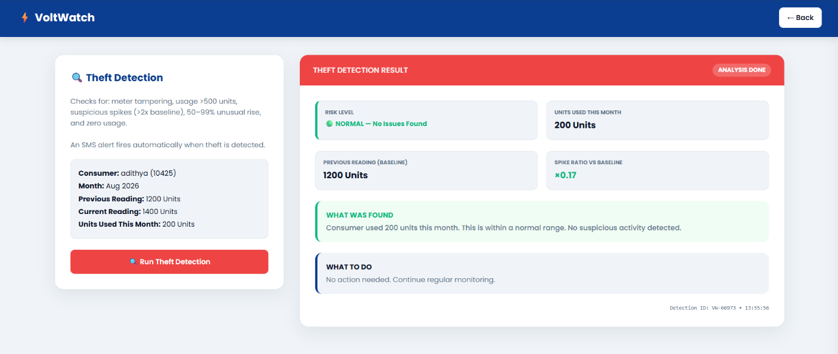
K. Dhanush Srivatsan – 33%
Responsible for electricity theft detection, consumption anomaly analysis, spike and drop detection, risk classification, and testing of fraud detection functionality.
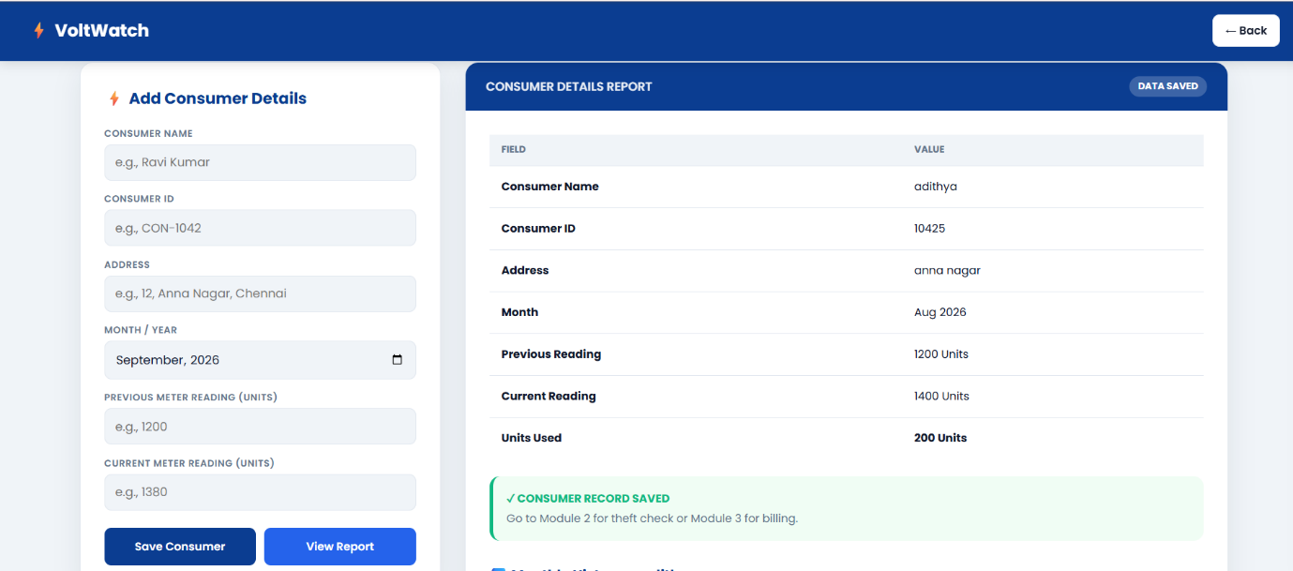

Mohamed Hasid – 33%
Responsible for billing anomaly detection, bill generation, report generation, testing, result analysis, and documentation.
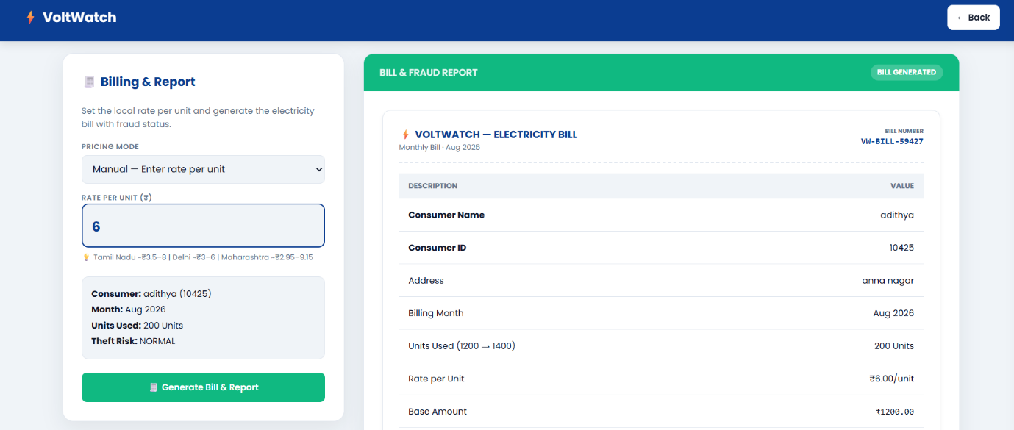
Total Contribution: 100%

CHAPTER 5
CONCLUSION, FUTURE WORK AND REFLECTION
5.1 Conclusion
The Electricity Theft Detection and Billing Anomaly System provides a C-based software solution for managing consumer electricity information, analyzing consumption patterns, detecting possible electricity theft, and identifying billing anomalies.
The system is divided into three major modules: consumer management, electricity theft detection, and billing anomaly detection. This modular structure makes it easier to understand, test, maintain, and extend the application.
The consumer management module maintains consumer records and meter readings. The theft detection module analyzes consumption patterns and identifies suspicious spikes, drops, and possible illegal connections. The billing module calculates electricity charges, identifies billing discrepancies, and generates reports.
The project demonstrates the practical use of structures, arrays, pointers, functions, and file handling in C programming.
Although the current implementation is a software simulation, it provides a foundation for developing a more advanced electricity monitoring system using smart meters, IoT devices, machine learning, web technologies, and mobile applications.
Electricity theft Detection(2) …

5.2 Future Work
Several improvements can be implemented in future versions of the system.
IoT Smart Meter Integration
The system can be connected to smart meters to automatically collect electricity readings instead of requiring manual data entry.
Real-Time Monitoring
Real-time electricity consumption monitoring can help identify suspicious activity immediately.
Artificial Intelligence and Machine Learning
Machine learning algorithms can be used to identify complex electricity theft patterns that cannot easily be detected using fixed thresholds.
Web Dashboard
A web-based dashboard can display electricity consumption, fraud alerts, billing information, graphs, and consumer statistics.
Mobile Application
A mobile application can allow consumers to view bills, monitor electricity consumption, and report suspicious activities.
Automated Notifications
SMS and email alerts can be sent automatically to authorities when suspicious electricity usage is detected.
Improved Security
Future versions can include authentication, role-based access control, encrypted data storage, and secure communication.
These improvements are consistent with the future enhancement directions identified in the PPT.
Electricity theft Detection(2) …

5.3 Professional Learning & Individual Reflection
New Knowledge Acquired
Through this project, knowledge was gained in:
- C structures.
- File handling.
- Arrays and pointers.
- Functions and modular programming.
- Electricity consumption analysis.
- Anomaly detection.
- Billing calculations.
- Fraud detection concepts.
- Software testing.

Recent References
- Mbey, C. F., et al. (2024). Electricity Theft Detection in a Smart Grid Using Hybrid Machine Learning Techniques. Journal of Electrical and Computer Engineering. IEEE (2024). IoT Based Power Theft Detection for Transmission Lines. 2024 5th International Conference on Smart Electronics and Communication (ICOSEC). DOI:
- Zibaeirad, A., Koleini, F., Bi, S., Hou, T., & Wang, T. (2024). A Comprehensive Survey on the Security of Smart Grid: Challenges, Mitigations, and Future Research Opportunities. arXiv
- Iqbal, M. S., et al. (2025). A Critical Review of Technical Case Studies for Electricity Theft Detection. Energy Reports, 2025.
- Kabir, B., et al. (2025). Detecting Electricity Theft in Smart Grids Using Optimized Machine Learning Ensemble Techniques and Explainable AI. Energy Reports, 14, 3142–3162. DOI: 10.1016/j.egyr.2025.09.019.
- Chen, X., Huang, C., & Wang, H. (2025). Smart Energy Guardian: A Hybrid Deep Learning Model for Detecting Fraudulent PV Generation.
- Blazakis, K., et al. (2025). Power Theft Detection in Smart Grids Using Quantum
- Labate, D., Thakur, D., & Fortino, G. (2026). Towards Secure and Scalable Energy Theft Detection: A Federated Learning Approach for Resource-Constrained Smart Meters.

